**Project Name:** Weather App

**Github Link:** https://github.com/projectsforstudents2022/Weather_App.git

**Why was this project created?**

The weather is a variable that never stays the same. People can better arrange their daily schedules when they are aware of the current weather conditions. As weather forecasting technology has advanced to the sky, many channels have been used to distribute the prediction. Users of weather applications can receive immediate alerts about the weather. The simplest way to learn about weather updates is through weather apps.

**What problem is it solving?**

The goal of this project is to develop a weather report application that users may use to forecast the weather on a third-party server. By integrating some remarkable features like weather updates that are happening all around the world and obtaining the weather prediction before leaving the house, this application is also designed to make people's lives easier. The goal of this project is to create an application with all the fundamental functions that users may access with a single click.

**Entire explanation of project**

* **PROPOSED APPROACH**

The code for this app is only HTML, CSS, and JavaScript. Regarding the system's characteristics, the user may forecast the probability of the current day's climate and determine whether the day will be sunny or overcast. Any city name in the globe may be entered by the user into the programme. The project's functionality is made possible by the extensive use of javascript.

Some new features, such as controlling and resolving exception errors directly by the system which will be invisible to the user, have been introduced to the web-based Weather Report project application to make it bug-free. The customer has a variety of options at their disposal, allowing them to choose different weather channels in accordance with their preferences and needs. Another benefit of this technology is that its pattern recognition system may use digital visuals to warn about dangerous weather conditions before they occur. When a user chooses a location for the system to use, the system will remember that location as the default and will not require the user to update it each time they use the system.

* **TECHNOLOGY STACK**

1. Javascript
2. Html
3. Css
4. MySql

* **DATA FLOW DIAGRAM**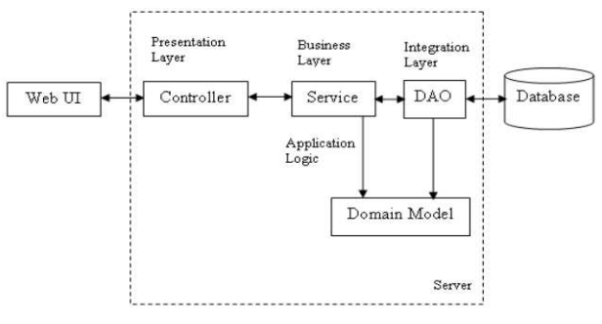
* **RESULT**

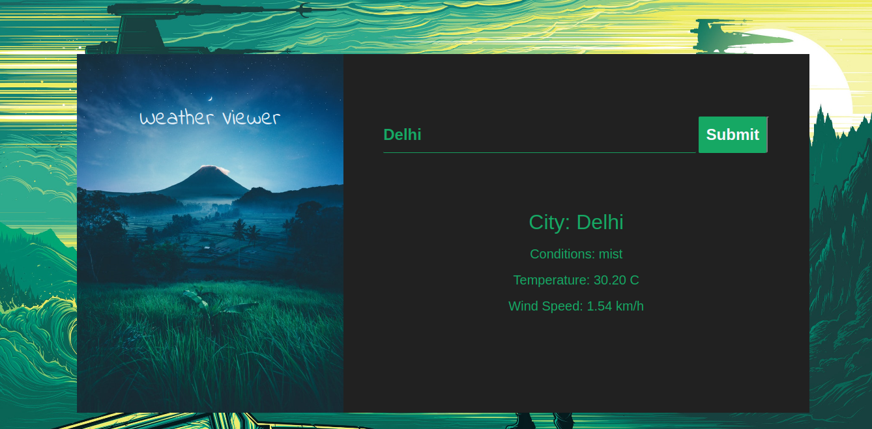

* **CONCLUSION**

Weather predictions are increasingly precise and valuable, and their advantages reach extensively across the economy. Weather predictions have come a long way, but there is still considerable opportunity for improvement. To make sure that forecasts and warnings suit each stakeholder's unique needs, the forecasting community collaborates closely with a variety of stakeholders. They are simultaneously creating new observational networks and technological advancements that will improve forecasters' abilities and the perceived value of their services to customers.